ADITHYA R
1922311369

18.Demonstrate Infrastructure as a Service (IaaS) by creating a resources group using a Public Cloud Service Provider (Azure), configure with minimum CPU, RAM, and Storage.
AIM: To demonstrate Infrastructure as a Service (IaaS) by creating a Resource Group and deploying a Virtual Machine with minimum CPU, RAM, and Storage configuration using Microsoft Azure.
PROCEDURE:
STEP 1: Login to Azure Portal
- Open a web browser.
- Go to Azure Portal: https://portal.azure.com
- Sign in using your Azure account credentials.
STEP 2: Create a Resource Group
- In the Azure Portal search bar, type Resource Groups.
- Click Create.
- Enter the following details:
  - Subscription: Select your subscription
  - Resource Group Name: IaaS-Demo-RG
  - Region: Select nearest region (e.g., Central India)
- Click Review + Create.
- Click Create.
✅ Resource Group successfully created.
STEP 3: Create a Virtual Machine (Minimum Configuration)
- In Azure Portal, click Create a Resource.
- Select Virtual Machine.
- Click Create.
Basic Configuration:
- Resource Group: Select IaaS-Demo-RG
- Virtual Machine Name: IaaS-Demo-VM
- Region: Same as Resource Group
- Image: Ubuntu Server 22.04 LTS (or Windows Server)
- Size (Minimum Configuration):
  - Example: Standard B1s
  - CPU: 1 vCPU
STEP 4: Configure Administrator Account
- Authentication type: Password
- Username: azureuser
- Password: Create a strong password
STEP 5: Configure Storage
- OS Disk Type: Standard SSD
- Storage Size: Default (Minimum ~30 GB)
STEP 6: Networking
- Allow Public inbound ports: Select SSH (22) (for Linux)
OR
- Select RDP (3389) (for Windows)
Click Review + Create → Create
⏳ Deployment will take 2–5 minutes.
STEP 7: Verify Deployment
- Go to Resource Group → IaaS-Demo-RG
- Check created resources:
  - Virtual Machine
  - Public IP
  - Network Interface
  - Virtual Network
  - Disk
Click Go to Resource → Connect via SSH/RDP to verify the VM is running.

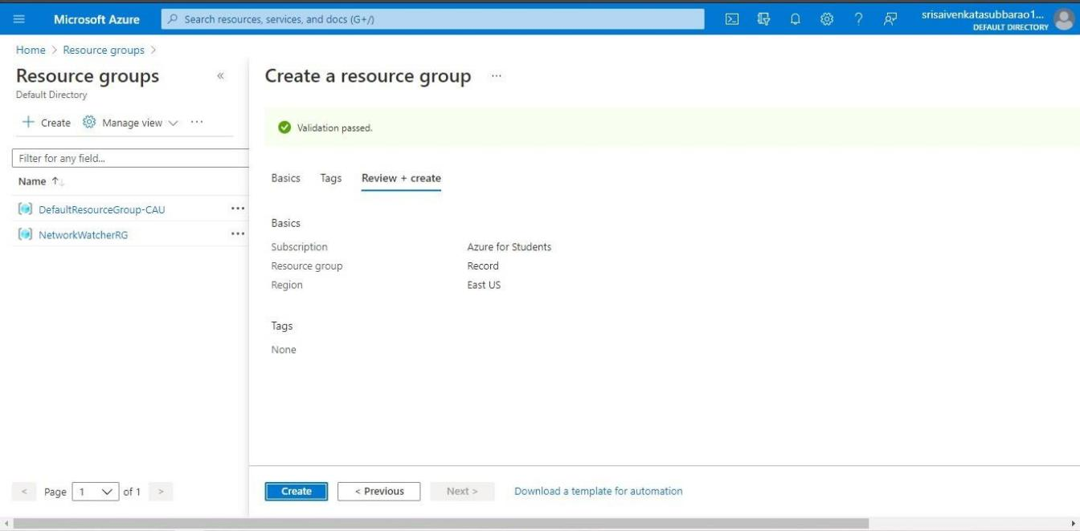
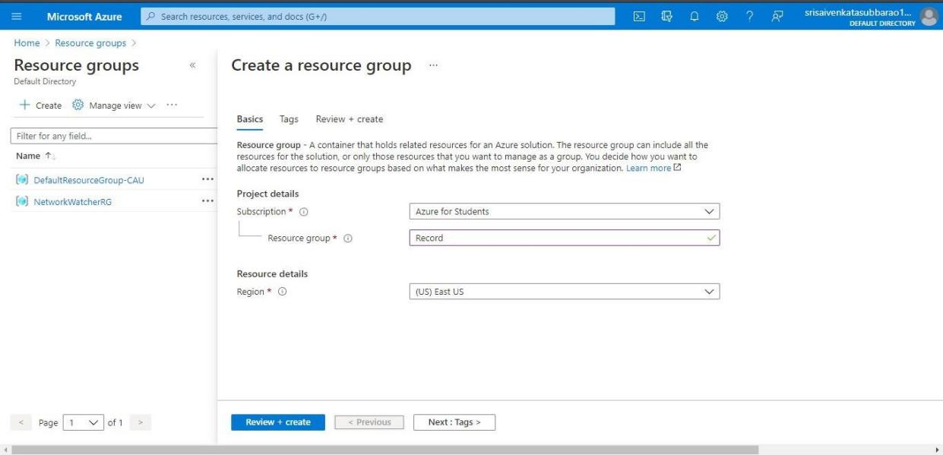
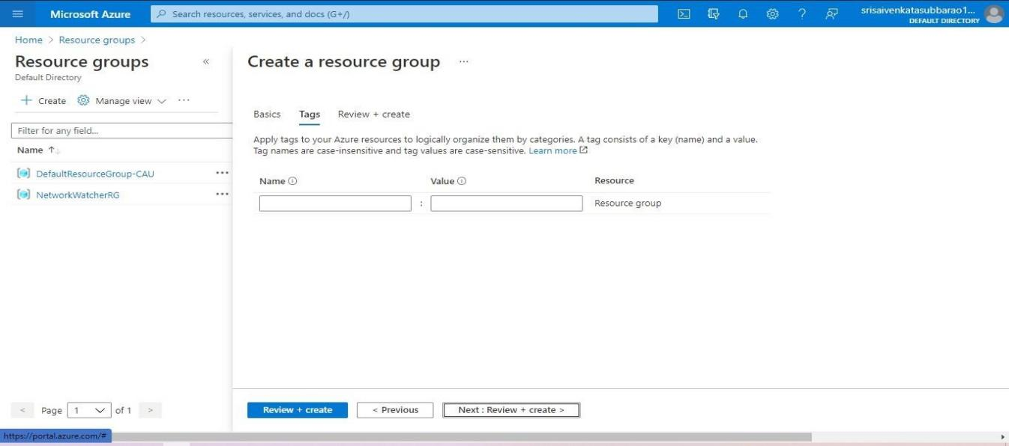

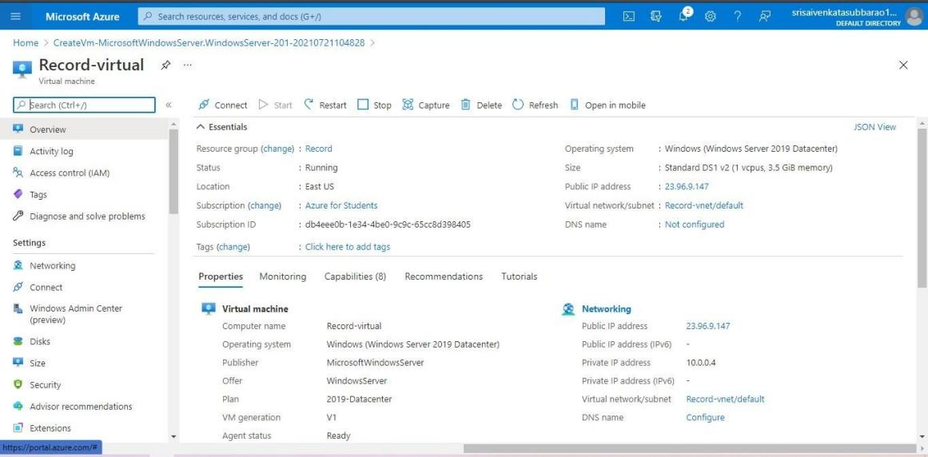
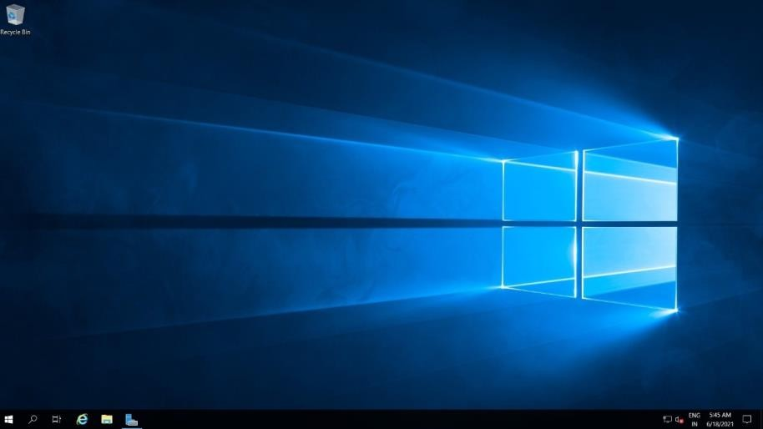

RESULT
The Resource Group and Virtual Machine were successfully created using Microsoft Azure under the IaaS model.
The VM was configured with:
- 1 vCPU
- 1 GB RAM
- 30 GB Storage
Thus, Infrastructure as a Service (IaaS) was successfully demonstrated using Microsoft Azure.

